September 6, 2016
RE: Grade 5 Get Active! Program

Dear: School District 43 Grade 5 Students and Parents/Guardians:

The Tri Cities, in cooperation with School District 43, are pleased to continue the Grade 5 Get Active! Program for all School District 43 Grade 5 students. This program has been approved by the Cities of Coquitlam, Port Coquitlam and Port Moody to promote youth involvement in physical activity. We are very excited about this community partnership and we hope that you will be able to take part in it.

This letter is required for registration. Grade 5 students must take this letter to the leisure services location that serves your home address, with your birth certificate and proof of residency (has to be phone, hydro, cable or gas bill or Property Tax Notice - driver's license and PO Boxes are not acceptable).
- Coquitlam residents register at Coquitlam Recreations locations;
- Port Coquitlam residents register at Port Coquitlam Leisure Services locations;
- Port Moody, Anmore & Belcarra residents register at Port Moody Recreation Centre
With this verification, you will receive a Grade 5 Get Active! Card – a photo identification card (student must be present for photo to be taken) that you can use from September 6, 2016 to September 4, 2017, to access all drop-in swimming, skating and gymnasium programs in Coquitlam, Port Coquitlam and Port Moody, all free of charge!

All Grade 5 students are encouraged to take advantage of this new opportunity. Think of the fun you can have while in grade 5 – public skating, unlimited access to the indoor and outdoor pools all summer, shooting hoops with your friends at City run drop in gym programs! All during your Grade 5 year.

There has never been a better time for you to Get Active!

Sincerely,
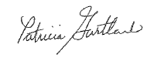

Superintendant of Schools
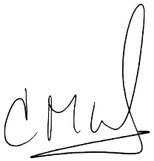
Grade 5 Student:

School Attending: Harbour View Elementary School

Verified by:
Grade 5 Teacher / School Administrator

